SEKOLAH KEBANGSAAN SUNGAI KAWI
D/A PPD MERADONG

96500 BINTANGOR

SARAWAK

NAME:

SCHOOL BASE ASSESMENT

WORLD OF SCIENCE AND TECHNOLOGY
018/1

PAPER 1

YEAR 1

MAC 2016

1 HOUR

I HOUR

DO NOT OPEN THIS QUESTION PAPER UNTIL YOU TOLD TO DO SO

- This paper consists of 25 questions and in dual language of Malay and English.
- Answers all questions.
- Circle one answer for each question.
- If you wish to change your answers, erase the circled one before and circle the new answer.
- If you have any confusion with the questions, you permitted to ask the invigilator for clarifications.

THIS QUESTION PAPER CONSISTS OF 13 PRINTED PAGES
ANSWER ALL QUESTION
JAWAB SEMUA SOALAN

Choose the correct answer and circle the correct answer.
Pilih jawapan yang betul dan bulatkan jawapan yang betul.

1. Which one of the following is a living things?
Antara yang berikut yang manakah benda hidup?

A
B | 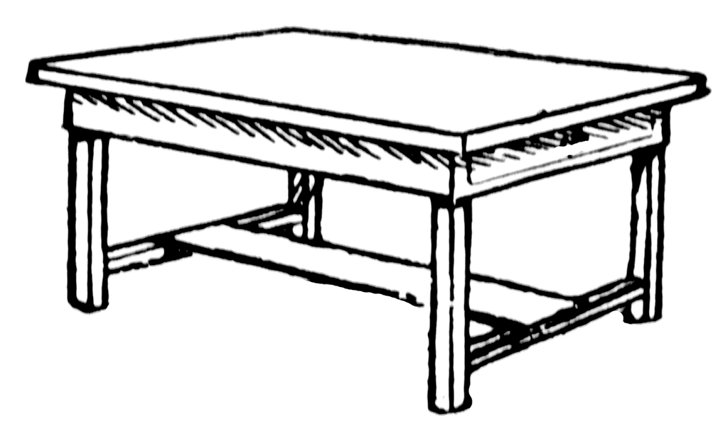
C

2. Living things _________________
Benda hidup _________________

A. Do need to breath
Tidak perlu bernafas
B. Able make their own food
Boleh membuat makanannya sendiri
C. Able to grow
Boleh membesar

3. Which group below is belonging to non-living things?
Antara kumpulan berikut yang manakah tergolong dalam benda bukan hidup?

A. | 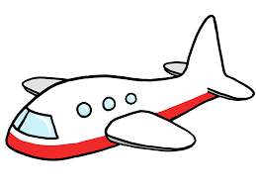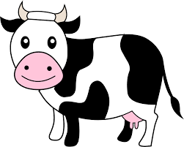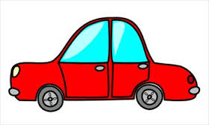
B. | 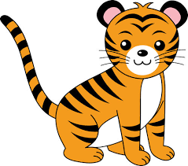
C. | 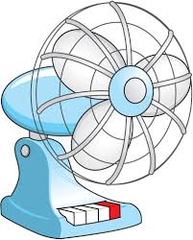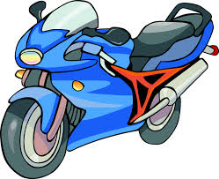

4. Which of the following is not the characteristic of living things?
Yang manakah antara berikut bukan ciri-ciri benda hidup?

A. Can make their own food
Boleh membuat makannya sendiri
B. Can reproduce
Boleh membiak
C. Can breathe
Boleh bernafas

5. Non-living things _______________
Benda tidak hidup _______________

A. Can grow
Boleh membesar
B. Need to eat and drink
Perlu makan dan minum
C. Cannot reproduce
Tidak boleh membiak

6. Diagram below shows a train
Gambar di bawah menunjukkan sebuah kereta api
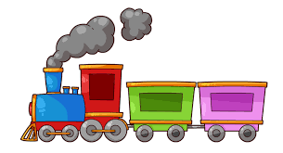
Choose the correct statement
Pilih pernyataan yang betul

A. It is a living thing
Ia adalah benda hidup
B. It can move itself
Ia boleh bergerak sendiri
C. It cannot reproduce
Ia tidak dapat beranak

7. Diagram below shows a lion
Gambarajah di bawah menunjukkan seekor singa
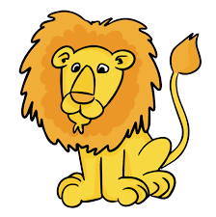
Choose the correct statement
Pilih pernyataan yang betul

A. It needs to eat and drink
Ia perlu makan dan minum
B. It cannot move itself
Ia tidak boleh bergerak sendiri
C. It does not need to breathe
Ia tidak perlu untuk bernafas

8. Characteristic for the diagram below is
Ciri bagi gambarajah di bawah adalah
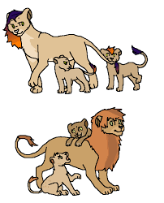
A. Can reproduce
Boleh membiak
B. Need to eat
Perlu makan
C. It can move itself
Ia boleh bergerak sendiri
9. Diagram below show that living things need to ________________
Rajah di bawah menunjukkan benda hidup perlu _______________

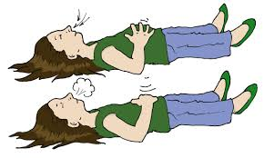
A. Breathe
Bernafas
B. Eat
Makan
C. Drink
Minum

10. Alya was very hungry. What does she need to do?
Alya berasa sangat lapar. Apakah yang perlu beliau lakukan?

A. Sleep
Tidur
B. Breathe
Bernafas
C. Eat & Drink
Maka & Minum

11. Based on the picture, it shows that plant is _________________
Berdasarkan kepada rajah, ia menunjukkan tumbuhan __________

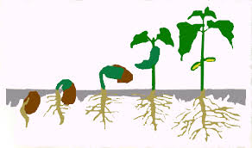
A. Moving
Bergerak
B. Growing
Membesar
C. Reproducing
Membiak

12. Diagram below shows that the chicken ________
Rajah di bawah menunjukkan ayam ___________

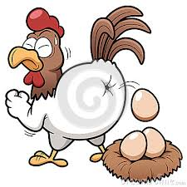
A. Reproducing
Membiak
B. Breathing
Bernafas
C. Defecating
Membuang najis

13. Living thing in the picture show that, he is ___________
Benda hidup di dalam rajah menunjukkan dia sedang _____

A. Eating
Makan
B. Moving
Bergerak
C. Breathing
Bernafas

14. Every living things need to __________, ___________ and _________
Setiap benda hidup perlu ___________, __________ dan ________

A. Eat, drink and sleep
Makan, minum dan tidur
B. Sleep, play and watching television
Tidur, bermain dan menonton televisyen
C. Breathe, moving and eat
Bernafas, bergerak dan makan

15. Why we cannot say that car is a living thing?
Mengapakan kita tidak boleh mengatakan bahawa kereta adalah benda hidup?
A. Car cannot move itself
Kereta tidak boleh bergerak sendiri
B. Car does eat and drink
Kereta makan dan minum.
C. Car reproduce
Kereta membiak.
16. Why does the mother of the chickens does as in the diagram?
Mengapakah ibu ayam melakukan seperti dalam rajah?
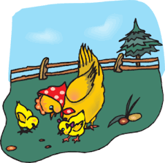
A. Because the chickens need to eat to stay alive
Kerana anak ayam perlu makan untuk hidup
B. Because the chickens need to drink to stay alive
Kerana anak ayam perlu minum untuk hidup
C. Because the chickens need air to stay alive
Kerana anak ayam perlu udara untuk hidup

17. Which of the following group is living things?
Yang manakah di antara berikut merupakan kumpulan benda hidup?

A. Chicken, Computer, Cat and Cow
Ayam, Komputer, Kucing dan Lembu
B. Durian tree, Lion, Fish and Mango tree
Pokok Durian, Singa, Ikan dan Pokok Mangga
C. Car, Lorry, Prawn and Lamp
Kereta, Lori, Udang dan Lampu.

18. Which of the following can move around by itself?
Yang manakah diantara berikut dapat bergerak sendiri?

A.
B.
C.

19. Which of the following can become bigger in after 2 year?
Yang manakah diantara berikut menjadi semakin besar selepas 2 tahun?

A. | 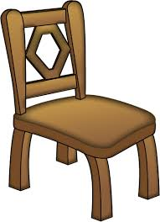
B. | 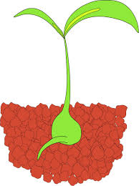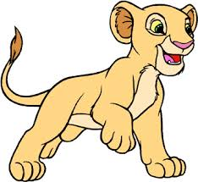
C. | 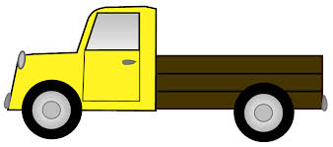
20. A lorry is not a living thing because _________________
Sebuah lori bukan benda hidup kerana _______________

A. Lorry does not breathe
Lori tidak bernafas
B. Lorry can move itself
Lori boleh bergerak sendiri
C. Lorry eats to stay alive
Lori makan untuk hidup

21. Farhana was very thirsty. What does Farhana need to do?
Farhana berasa sangat dahaga. Apakah yang perlu Farhana lakukan?

A. Breathe deeply
Bernafas sedalamnya
B. Eat a plate of rice
Makan sepinggan nasi
C. Drink a glass of fresh orange
Minum segelas jus oren.

22. Nyalung walks from his house to school. This show that Nyalung can ___________.
Nyalung berjalan dari rumahnya ke sekolah. Ini menunjukkan __________

A. Breathing
Bernafas
B. Moving
Bergerak
C. Eats and Drinks
Makan dan Minum

23. Which of the following need to eat and drink?
Yang manakah di antara berikut perlu makan dan minum?

A. | 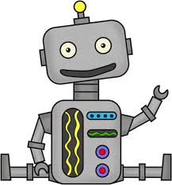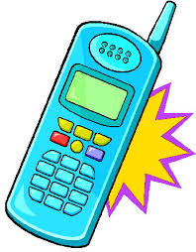
B. | 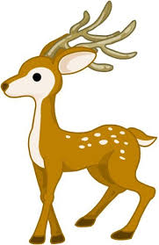
C.

24. Why do car is not a living thing even it can move?
Mengapakah kereta benda bukan hidup walaupun ia dapat bergerak?

A. Because car drinks water
Kerana kereta minum air
B. Because car cannot move if the is no driver and fuel
Kerana kereta tidak dapat bergerak sekiranya tiada pemandu dan petrol
C. Because car can produce
Kerana kereta boleh membiak

25. The diagram below shows that, the cat need to ____________
Rajah di bawah menunjukkan kucing perlu ________________

A. Eat
Makan
B. Drink
Minum
C. Breathe
Bernafas

-Soalan Tamat-
-Questions End-

GOOD LUCK
Semoga Berjaya

